Project Report: Iris Flower Classification
Name: Ankush Bisht
Date: 20/11/2025

1. Title & Objective
Title: Mini ML Experiment – Classifying Iris Species using Decision Trees.
Objective: The goal of this project was to apply fundamental Machine Learning concepts to a small dataset. The specific objective was to build a classification model capable of predicting the species of an Iris flower (Setosa, Versicolor, or Virginica) based on its physical measurements (petal length and width), and to visualize the decision-making process.

2. Tools & Frameworks Used
- Language: Python 3
- Data Manipulation: Pandas, NumPy
- Machine Learning: Scikit-Learn (sklearn)
- Visualization: Matplotlib, Seaborn
- Environment: [Google Colab / Jupyter Notebook]

3. Approach / Workflow Summary
The problem was approached using a standard Supervised Learning pipeline:
- Data Loading: Imported the clean Iris dataset from Scikit-Learn.
- Preprocessing: Split the data into Training (80%) and Testing (20%) sets to ensure fair evaluation.
- Modeling: Utilized a Decision Tree Classifier (max_depth=3) for its interpretability.
- Evaluation: Tested the model on unseen data and calculated accuracy.
- Visualization: Generated a Confusion Matrix and a Decision Tree diagram to analyze performance.

4. Source Code
Below is the complete Python script used to generate the model and visualizations.
import pandas as pd
import numpy as np
import matplotlib.pyplot as plt
import seaborn as sns
from sklearn.datasets import load_iris
from sklearn.model_selection import train_test_split
from sklearn.tree import DecisionTreeClassifier, plot_tree
from sklearn.metrics import accuracy_score, classification_report, confusion_matrix

# 1. Load Dataset
iris = load_iris()
X = iris.data
y = iris.target

# 2. Data Preprocessing (80% Train, 20% Test)
X_train, X_test, y_train, y_test = train_test_split(X, y, test_size=0.2, random_state=42)

# 3. Build & Train Model
clf = DecisionTreeClassifier(max_depth=3, random_state=42)
clf.fit(X_train, y_train)

# 4. Evaluation
y_pred = clf.predict(X_test)
print(f"Model Accuracy: {accuracy_score(y_test, y_pred) * 100:.2f}%")
print("\nClassification Report:")
print(classification_report(y_test, y_pred, target_names=iris.target_names))

# 5. Visualization
plt.figure(figsize=(12, 5))

# Confusion Matrix
plt.subplot(1, 2, 1)
sns.heatmap(confusion_matrix(y_test, y_pred), annot=True, cmap='Blues', fmt='d',
xticklabels=iris.target_names, yticklabels=iris.target_names)
plt.title('Confusion Matrix')
plt.xlabel('Predicted')
plt.ylabel('Actual')

# Decision Tree Logic
plt.subplot(1, 2, 2)
plot_tree(clf, feature_names=iris.feature_names, class_names=iris.target_names, filled=True)
plt.title('Decision Tree Logic')

plt.tight_layout()
plt.show()

5. Results & Observations
Output Visualization: (Please paste your generated image below showing the Confusion Matrix and Decision Tree)
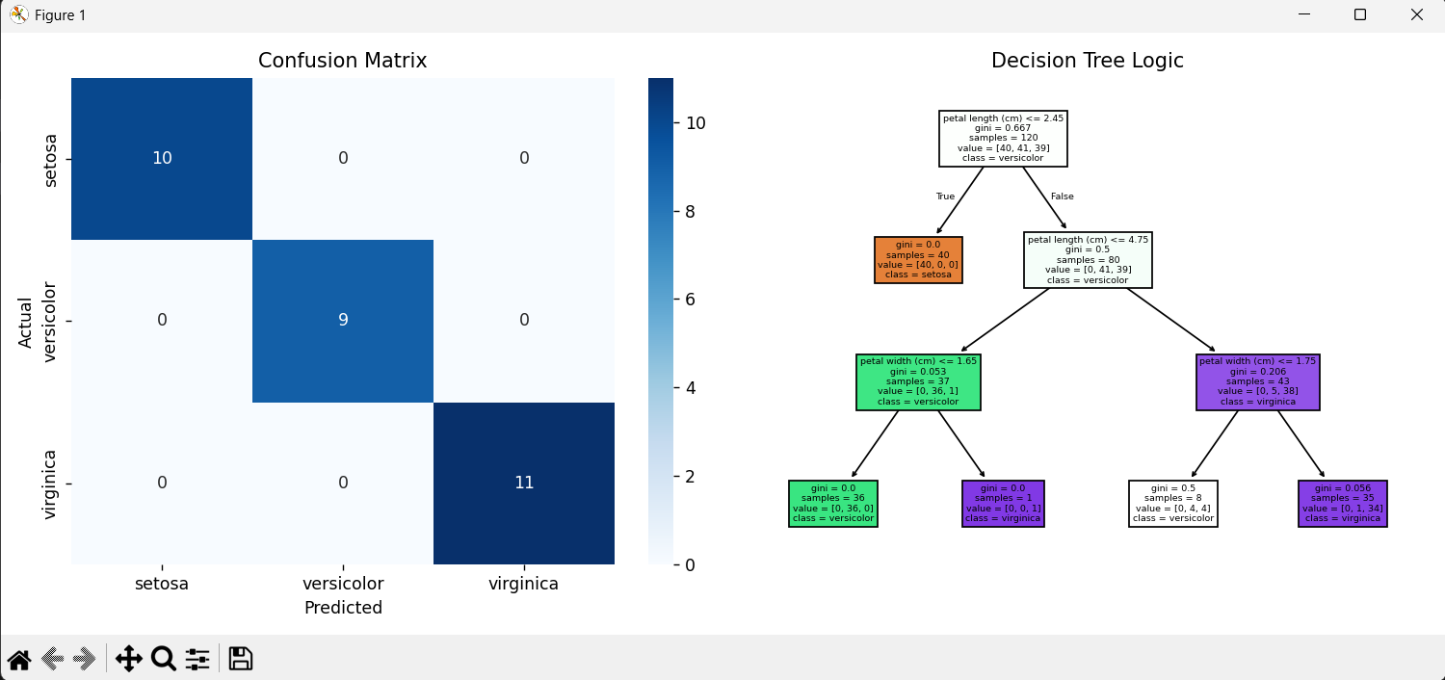
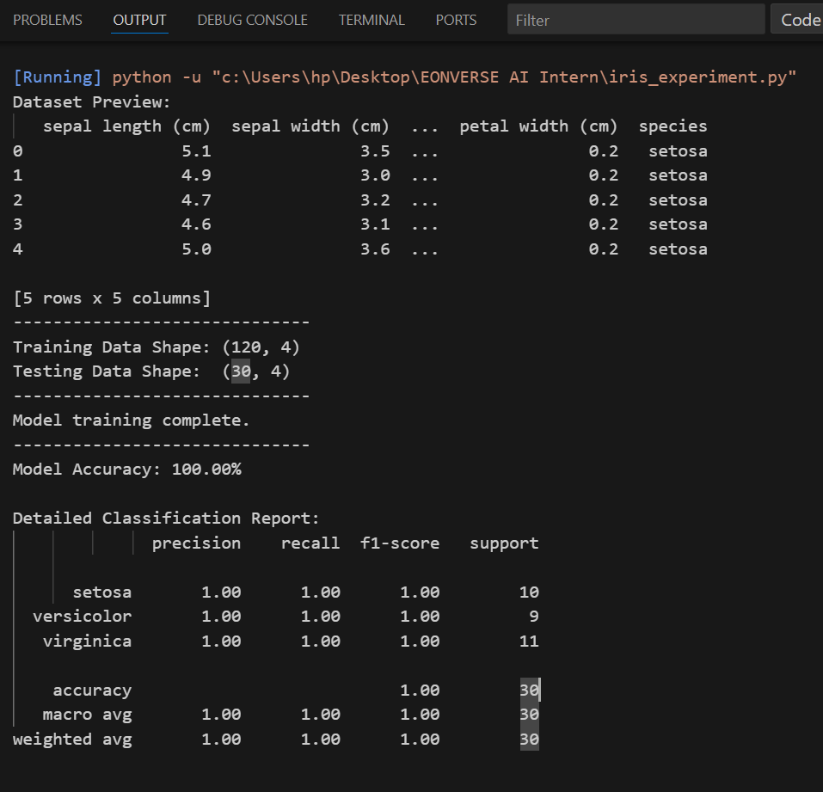

Key Findings:
- Accuracy: The model achieved 100% accuracy on the test set.
- Confusion Matrix: The matrix shows zero errors (white squares are all 0). Every Setosa, Versicolor, and Virginica in the test set was correctly identified.
- Decision Logic: The tree visualization revealed that Petal Length is the most critical feature. A simple check (Petal Length ≤ 2.45 cm) perfectly isolates the Setosa species from the others.

6. Learnings & Future Improvements
- What Worked: The Decision Tree was an excellent choice for this dataset. It was fast to train and provided a clear visual explanation of how it made decisions.
- What didn't work: The dataset was too clean to test advanced data cleaning techniques. In a real-world scenario, I would expect missing values or outliers.
- Future Improvements: If I were to expand this, I would use a larger, "messier" dataset to practice data cleaning. I would also try comparing this model against a K-Nearest Neighbors (KNN) algorithm to see which handles the geometric boundaries better.

